**Simple Auto Encoder**

**Case : 1**

Learning rate = 0.001

No. of steps = 12001

Optimizer = AdamOptimizer

**Graph** plotted in the **tensor board**

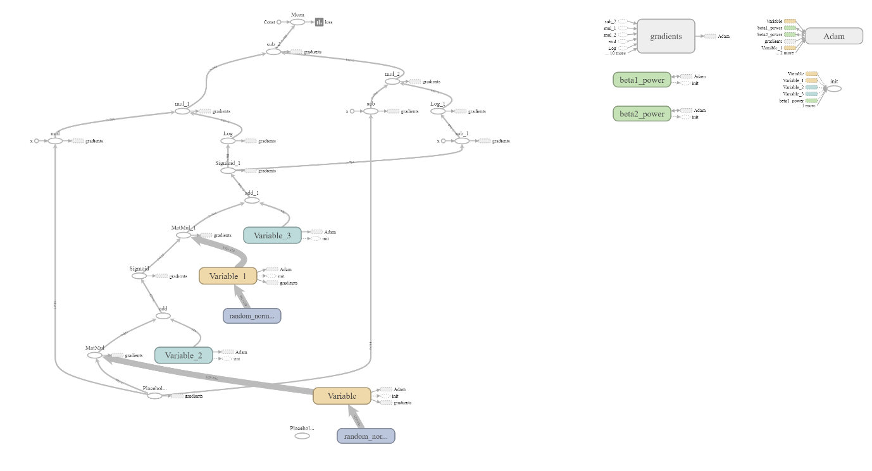

**Loss** plotted in the **tensor board** for the above values

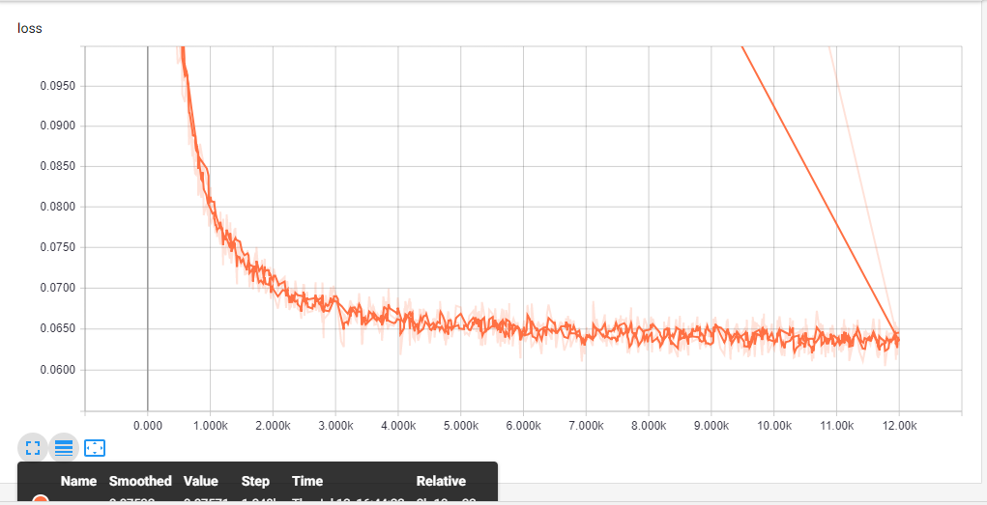

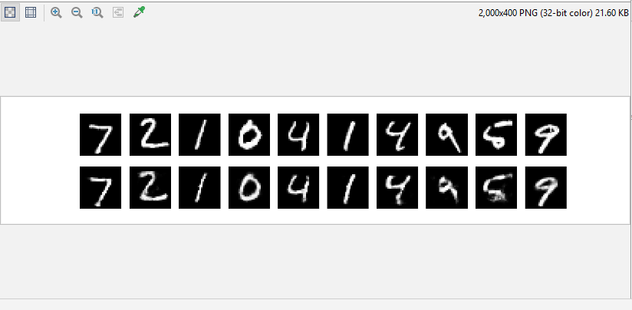

**Case : 2**

Learning rate = 0.1

No. of steps = 1000

Optimizer = RMSPropOptimizer

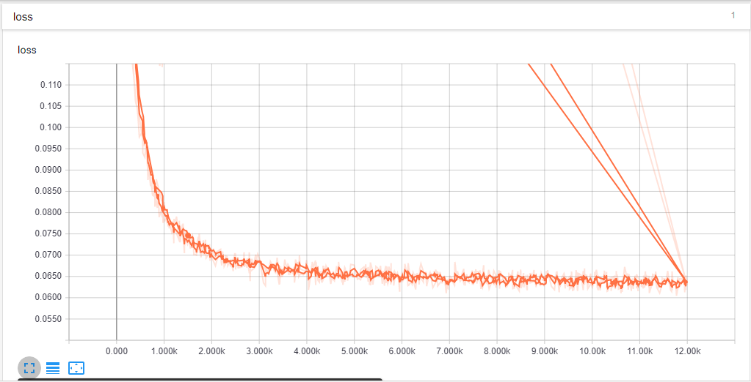

**Stacked Auto Encoder**

**Case : 1**

Learning rate = 0.01

No. of steps = 500

Optimizer = RMSPropOptimizer

**Output**

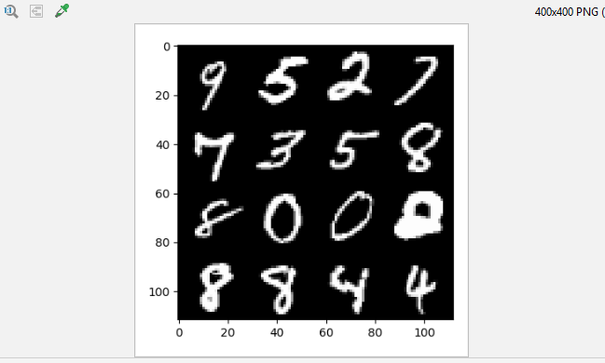

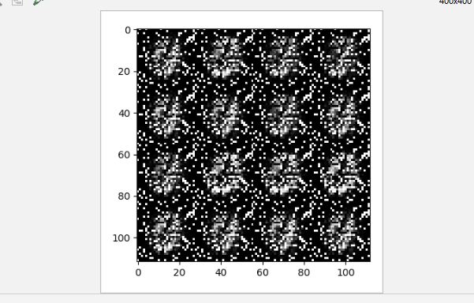

**Graph** plotted in the **tensor board**

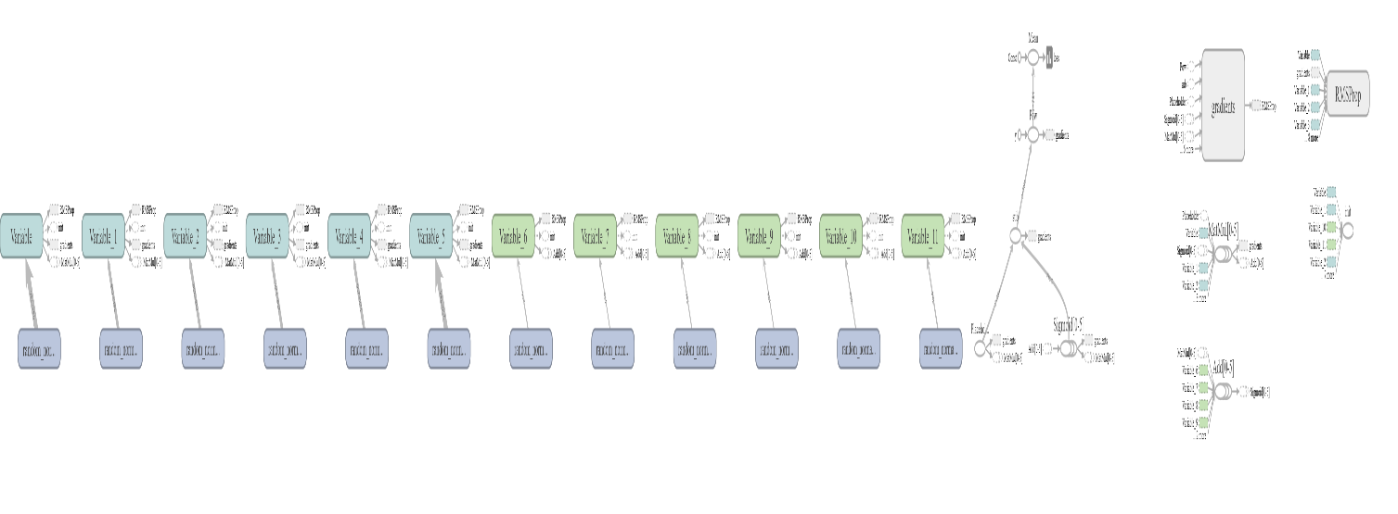

**Loss** plotted in the **tensor board** for the above values

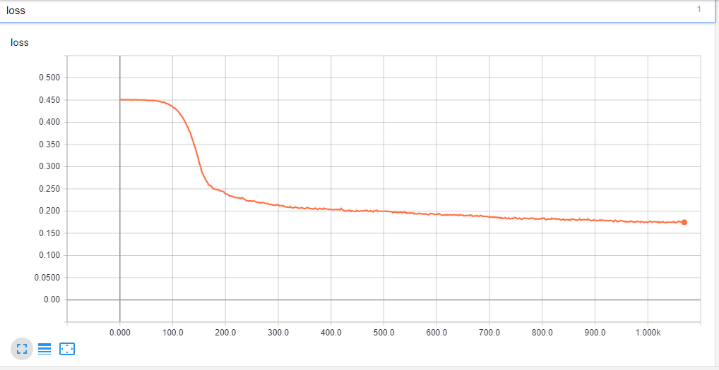

**Case : 2**

Learning rate = 0.1

No. of steps = 2000

Optimizer = AdamOptimizer

